Project Documentation — Memorae Website Redesign (Hackathon Submission)

1. Project Overview
This project is a complete frontend redesign of the Memorae website (https://memorae.ai/en/) created for a hackathon challenge.
The goal was to rebuild the website with a modern UI/UX, improved responsiveness, smooth animations, and a cleaner component structure using React.
Your redesign focuses on:
- A refreshed hero section with a modern gradient 3D blob illustration.
- A clean and minimal navigation bar.
- Improved CTA emphasis and content readability.
- A consistent color scheme with smooth transitions.

2. Objectives
- Redesigned the original Memorae website with a fresh, modern, and clean visual style using gradients, soft colors, and improved typography.
- Used a component-based React architecture, ensuring reusable UI elements and efficient code organization.
- Implemented React Router to create smooth page navigation without full page reloads.
- Built a responsive layout optimized for all screens—desktop, tablet, and mobile—using Flexbox, Grid, and scalable units.
- Designed a mobile-first UI, making sure spacing, scaling, and alignment adapt naturally across breakpoints.
- Produced a visually striking hero section with a 3D gradient blob illustration, bold headline, and strong CTA.
- Added smooth animations using Framer Motion and CSS transitions for hero elements, hover effects, and section reveals.
- Improved visual hierarchy using larger headings, clear subtitles, consistent spacing, and easy-to-read content flow.
- Enhanced user flow by ordering sections logically: Hero → How It Works → Features → Pricing → FAQ → Contact.
- Maintained a consistent and modern design language throughout the site, improving clarity, engagement, and UX.

3. Tech Stack

Category | Technology
Frontend Framework | React.js (CRA)
Styling | CSS
Animations | Framer Motion
Routing | React Router
Assets | Custom gradient 3D illustration
Deployment | GitHub Pages

4. Project Structure
src/
├── components/
│ ├── Header.jsx
│ ├── Footer.jsx
│ └── Button.jsx
├── pages/
│ ├ Home.jsx
│ ├ Features.jsx
│ ├ HowItWorks.jsx
│ ├Pricing.jsx
│ ├FAQ.jsx
│ |─ Contact.jsx
├── assets/
│ |─ images.png
├── App.js
|── index.js

5. Visual Design Breakdown
5.1 Header
- Left: Logo (Memorae text + blob icon)
- Center: Navigation links
How it Works | Features | Pricing | FAQ | Contact
- Right: CTA button → Sign Up
- Fixed at top with slight shadow.
5.2 Hero Section
Elements visible in the video:
- Large gradient floating 3D blob illustration (main hero graphic).
- Big title:
"Mindful Knowledge Storage"
with a stylish cursive orange font.
- Subtitle:
Organize, remember and grow your ideas beautifully.
- Primary CTA: Get Started (orange button)
- Soft peach / gradient background
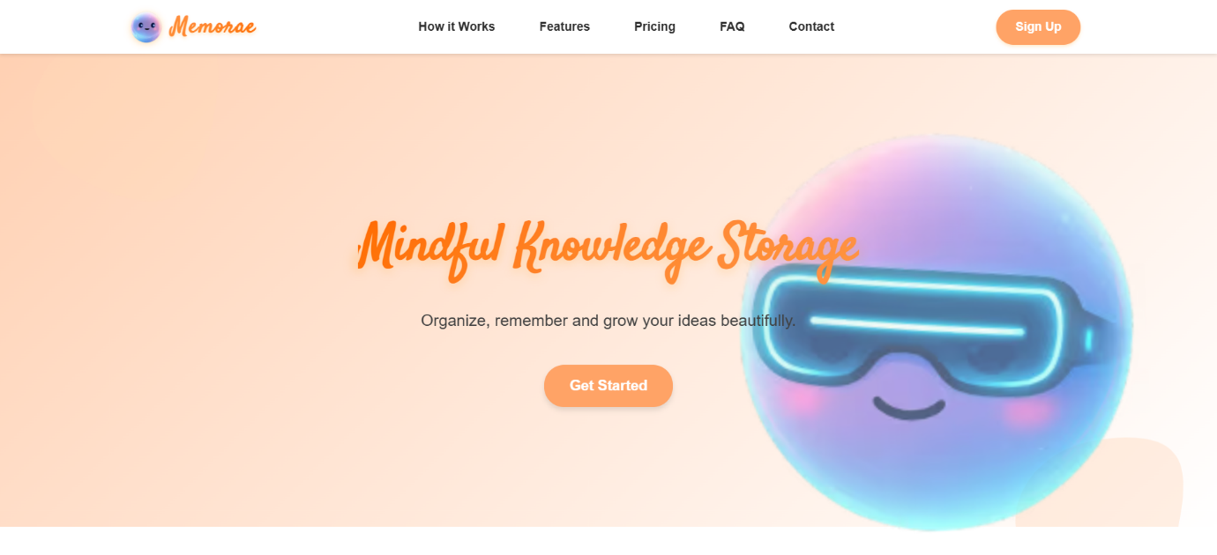

5.3 Buttons
- Rounded corners
- Orange gradient
- Hover animation (scale, shadow)
5.4 Layout Style
- Smooth spacing
- Light, minimal color palette
- Rounded UI components
- Modern typography
6. Pages to Build (Based on your redesign & original site)
Home Page
- Hero section (shown in your video)
- Why Memorae
- Key features
- Workflow preview
- Pricing CTA
- Footer
✅ How It Works
- Step-based explanation
- Illustrations or icons
- Animations on scroll
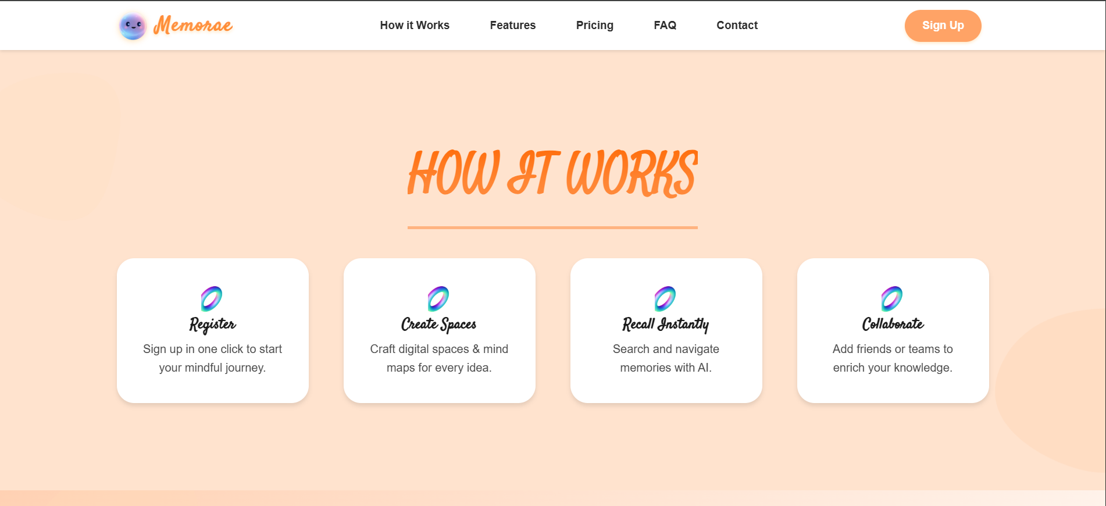

✅ Features Page
- List of top features
- Cards with icons
- Highlighted benefits
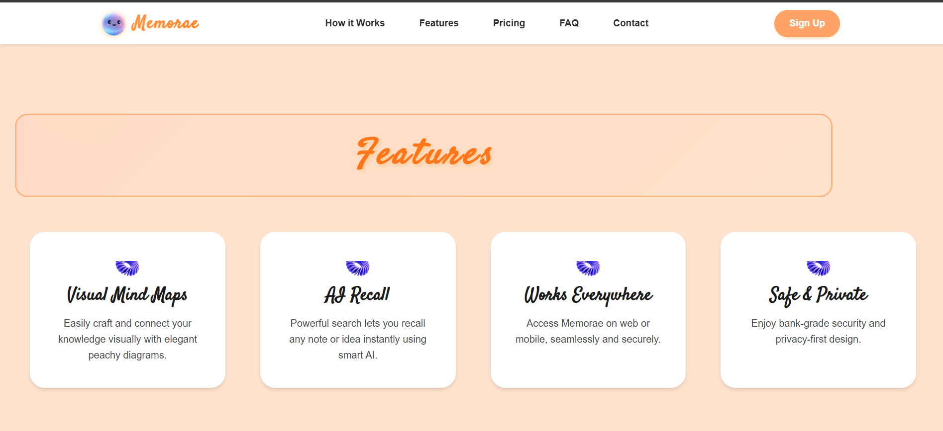

✅ Pricing Page
- Free vs Pro plans
- Features comparison table
- "Start Free" button
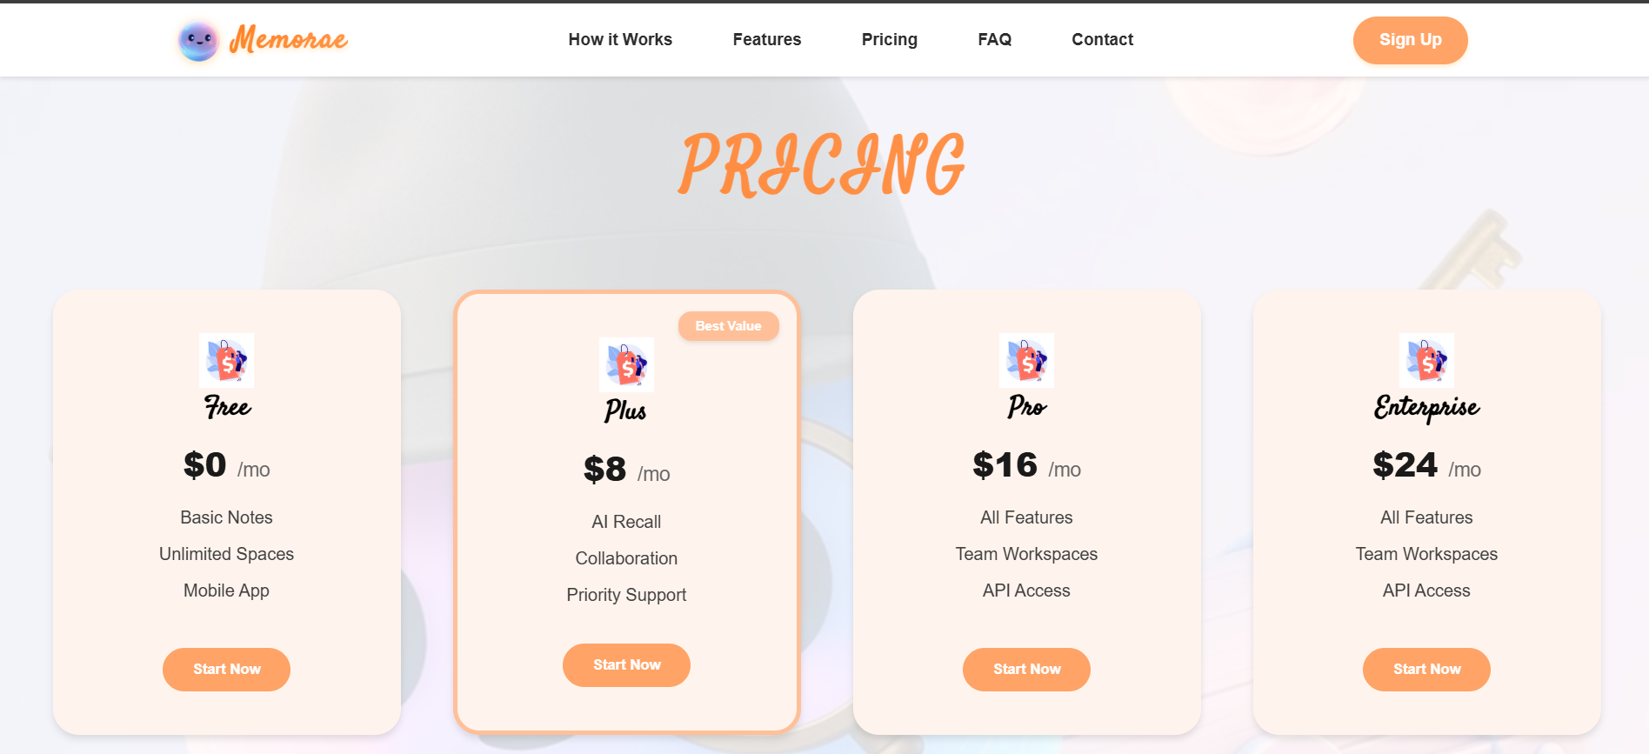

✅ FAQ Page
- Toggle-based FAQ accordion 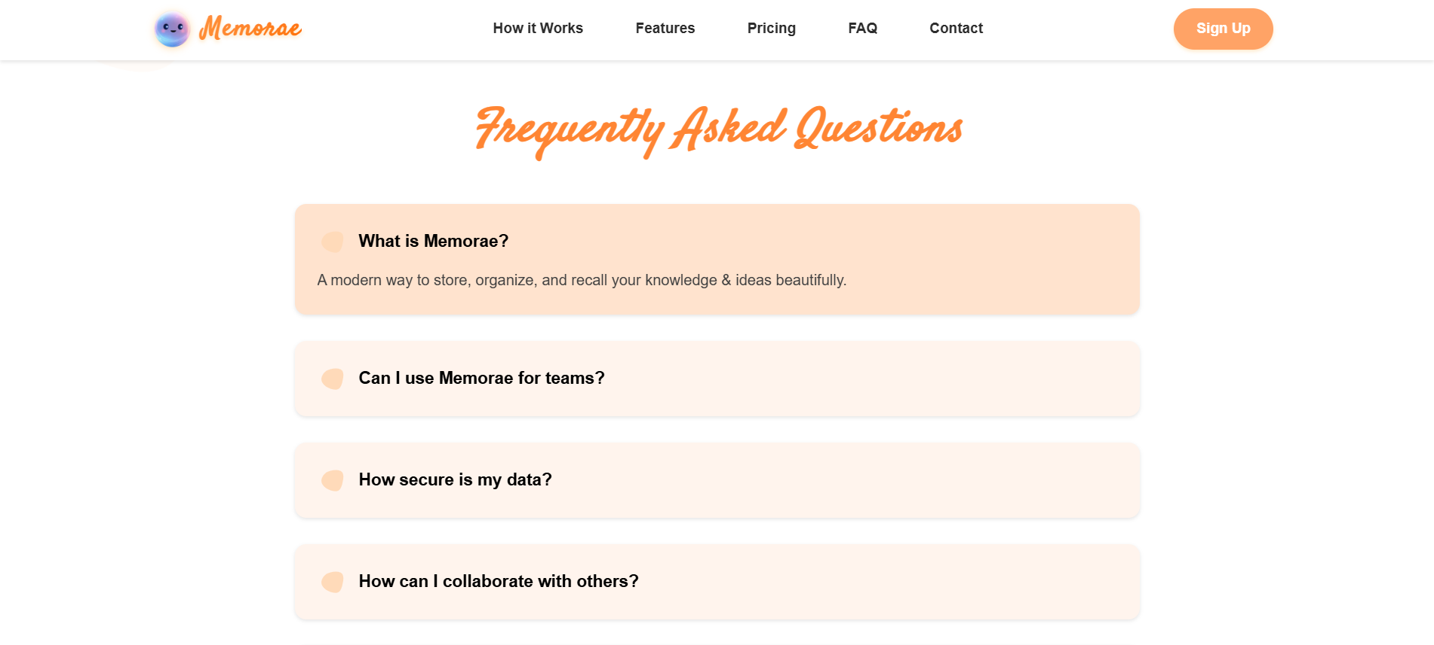

✅ Contact Page
- Simple form
- Basic inputs: name, email, message
- Submit animation
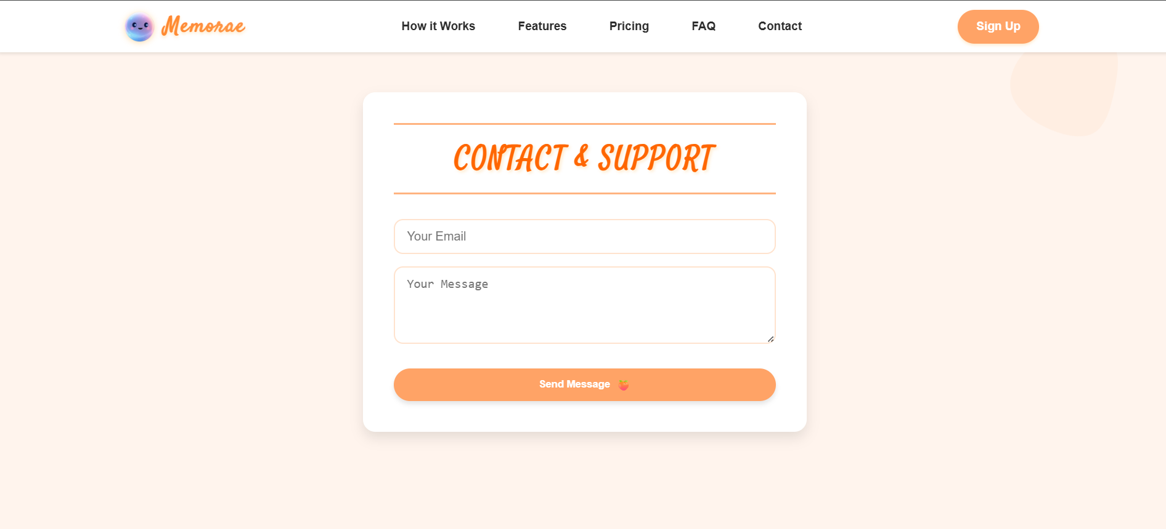
7. Core Functionalities
Although this is a purely frontend-oriented project, it delivers a complete and polished user experience through several essential functionalities:
✔ Smooth Scrolling Navigation
The website includes smooth scroll behavior to provide a seamless transition between sections. Whether the user clicks a navigation link or scrolls manually, the movement feels fluid and uninterrupted, enhancing the browsing experience.
✔ Interactive Hero Section
The hero banner includes micro-interactions and soft animations that draw the user's attention to the main product message and primary call-to-action. These visuals give the landing page a modern, premium feel.
✔ Section-wise Animations
Features, pricing cards, and information blocks appear with gentle fade-in or slide-in animations using Framer Motion and CSS transitions. This adds life to the page and improves content consumption without overwhelming the user.
✔ Fully Responsive Design
The website adapts smoothly to different device sizes:
- Desktop: Wide, well-spaced layout with visual balance
- Tablet: Adjusted grid, centered content, optimized text sizes
- Mobile: Stack-based layout, collapsible menu, enlarged buttons
Responsiveness ensures accessibility and usability across all platforms and screen resolutions.
✔ Reusable and Clean Components
Each UI section is built as an independent, reusable React component, making the project easy to maintain and scale. Headers, footers, cards, CTAs, and layout elements can be reused throughout the app with minimal code duplication.
✔ Fast Performance & Lightweight Build
Built with React and optimized assets, the website loads quickly and delivers a smooth interactive experience without unnecessary scripts.

8. How to Run the Project
The project supports both Vite and Create React App (CRA) setups, letting developers choose their preferred environment.

▶ Running with Vite
- Install dependencies:
- npm install
- Start development server:
- npm run dev
- Open the local development URL provided in the terminal.

▶ Running with Create React App (CRA)
- Install dependencies:
- npm install
- Start the app:
- npm start
- The application will automatically open on http://localhost:3000.

Deployment Recommendation
You can deploy this project easily using:
- Vercel
- Netlify
- GitHub Pages
These platforms auto-detect React and provide fast, secure hosting ideal for hackathon/demo submissions.

9. Key Improvements Over the Original Site
The redesigned version delivers several major UI and UX improvements:
⭐ Hero Section Modernization
The hero banner now features:
- Cleaner, more attractive typography
- A vibrant gradient 3D illustration
- A strong, visible primary CTA button
This immediately elevates the visual appeal and brand perception.
⭐ Visually Engaging Graphics
The original simple design is replaced with smooth gradients, soft shadows, and glowing visual elements that feel futuristic and friendly.
⭐ Improved Layout & Spacing
Consistent spacing, balanced margins, and improved alignment make the overall design easier to read and navigate.
⭐ Smooth Micro-Animations
Soft animations on scroll, hover effects, and interactive components give the interface a dynamic feel without distracting the user.
⭐ Better CTA Visibility
The “Get Started” and “Sign Up” buttons are stronger and more clickable, increasing potential conversion rates.
⭐ Cleaner and More Intuitive Navigation
Navigation is simpler, more readable, and visually consistent. The design supports quick scanning and effortless movement across pages.
These improvements collectively help the redesigned website feel more polished, engaging, and user-friendly than the original version.
10. Conclusion
This redesigned Memorae website successfully transforms the original interface into a modern, visually rich, and user-friendly digital experience.
By leveraging React best practices, reusable components, smooth animations, and fully responsive layouts, the project achieves a professional-quality frontend redesign suitable for both real-world use and hackathon presentation.
The documentation outlines:
- The intent and design philosophy
- The technical structure
- The improvements and advantages of the new design
- The steps to run and demonstrate the project
Overall, this project showcases strong UI/UX design thinking, attention to detail, and modern frontend development skills—making it an excellent fit for your hackathon submission.

